NORMAL

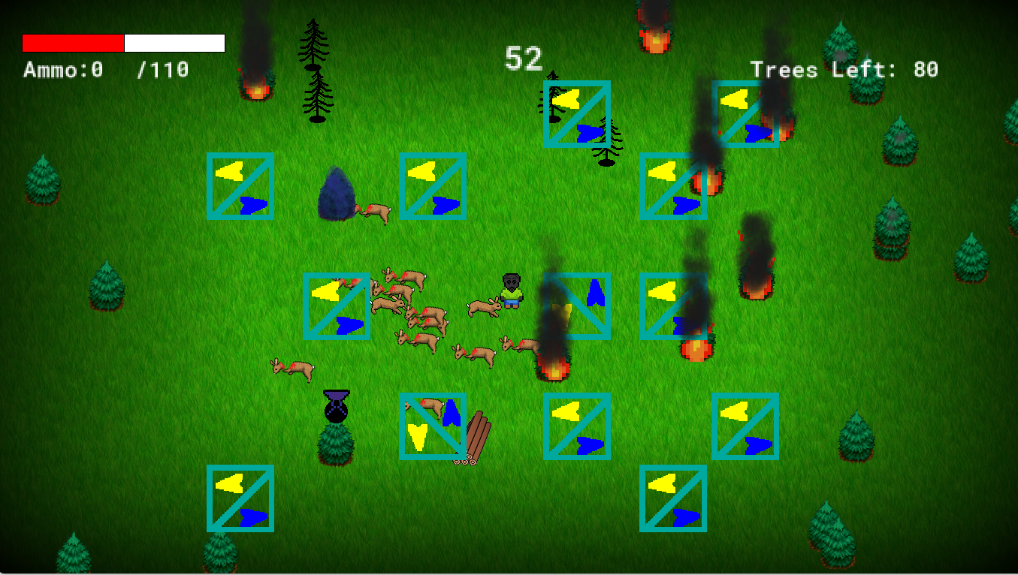

RED-WEAK/PROTANOMALY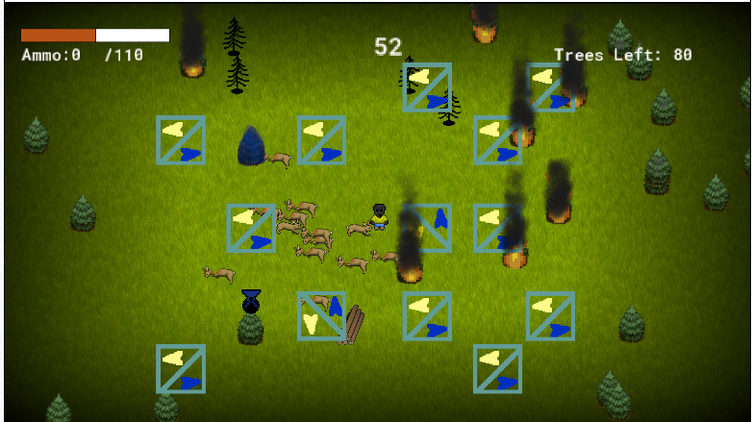

GREEN-WEAK/DEUTERANOMALY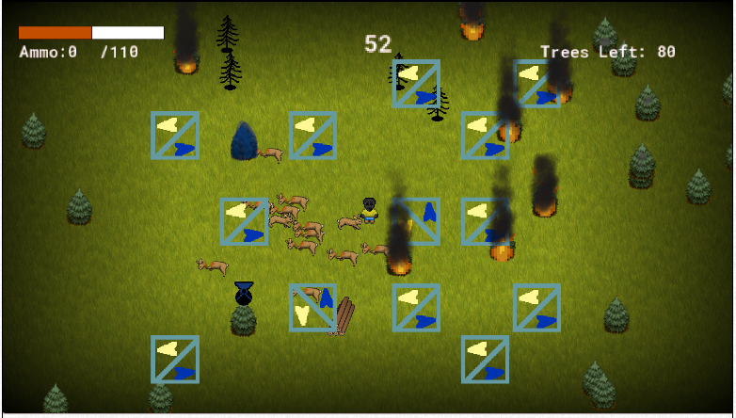BLUE-WEAK/TRITANOMALY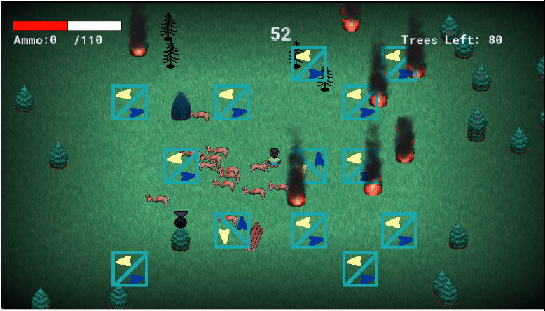RED-BLIND/PROTANOPIA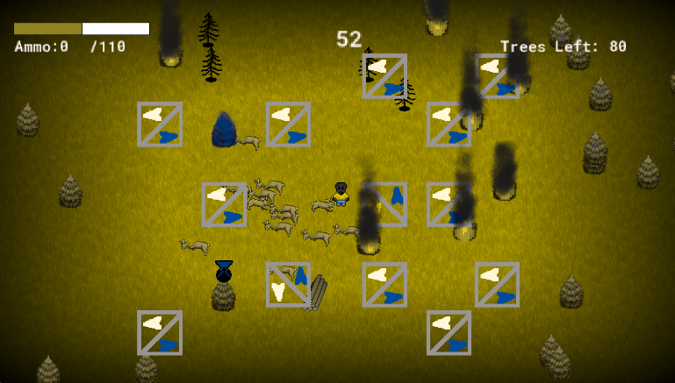GREEN-BLIND/DEUTERANOPIA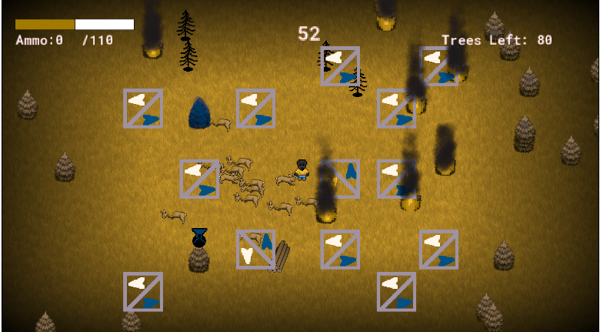

BLUE-BLIND/TRITANOPIA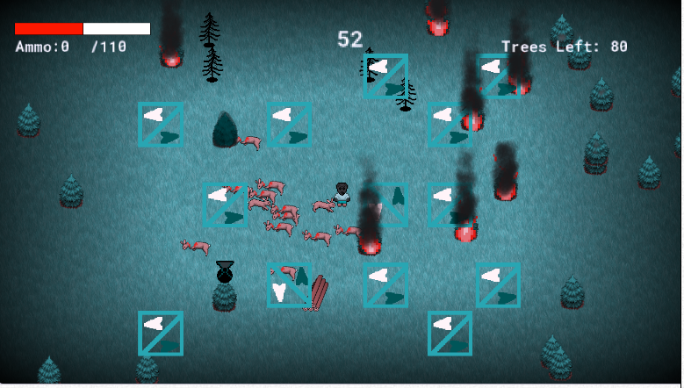Monochromacy/Achromatopsia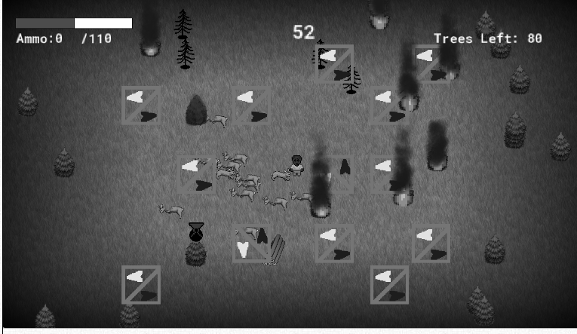Blue Cone Monochromancy